Title
A machine learning approach to measure energ savings in smart buildings
Applied data analytics in smart buildings for measuring energy savings
Authors

Abstract
[Why we did it]
Many efforts from several organisms are focused on the increasement of energy efficiency. It is on the interest of everybody, from particulars to governments, since energy efficiency yields to economical savings for households and companies, reduces greenhouse gas emissions benefiting environment, helps alleviate energy poverty and contributes to growth and jobs.
Before implementing an energy efficiency solution, it is neccesary to define the relationship which exists between energy use and the current operating conditions in order to determine energy savings that result form the implementation of the solution.
[How we did it]
We propose a machine learning approach for the creation of an energy consumption prediction model that is used to estimate the energy consumption in normal operation state, i.e., if the system would not have been altered by the solution. This allows us to compare the predicted for normal operating state and the actual consumption in order to quantify the energy savings.
[Results]
Our method shows better prediction accuracy than the so-called white box methods.

Introduction
[Explain why electricity demand forecasting is useful]
Energy consumption of buildings in developed countries comprises 20–40% of total energy use and is above industry and transport in EU and US. The awareness

Large and attractive opportunities exist to reduce buildings’ energy use at lower costs and higher returns than in other sectors
Energy management

When it comes to energy saving, energy management is the process of monitoring, controlling, and conserving energy in a building or organization. Typically this involves the following steps:
- Metering your energy consumption and collecting the data.
- Finding opportunities to save energy, and estimating how much energy each opportunity could save. You would typically analyze your meter data to find and quantify routine energy waste, and you might also investigate the energy savings that you could make by replacing equipment (e.g. lighting) or by upgrading your building's insulation.
- Taking action to target the opportunities to save energy (i.e. tackling the routine waste and replacing or upgrading the inefficient equipment). Typically you'd start with the best opportunities first.
- Tracking your progress by analyzing your meter data to see how well your energy-saving efforts have worked.

Evaluation, measurement, and verification (EM&V) is the collection of methods and processes used to assess the performance of energy efficiency activities so planned results can be achieved with greater certainty and future activities can be more effective.
The main objectives of an EM&V process are to assess the performance of an energy efficiency program or project, to measure the energy or demand savings, and to determine if the program is generating the expected level of savings.

[Expalin why we choose data analytics]

With recent advances in sensor and communication technologies, the generation of data about our surrounding environment and ourselves is explosively growing in terms of \emph{velocity}, \emph{variety} and \emph{volume} \cite{ali2014}. The treatment of huge data sets challenges traditional technologies and promotes the emergence of \textbf{Big Data} tools in order to capture, store, manage and analyze such data. In this context, \textbf{Internet of Things (IoT)} is one of the key enablers of \textbf{Smart Cities}. We are part of a new \emph{Era} where sensing technologies are being exploited to create innovative services for Citizens and Service Providers.
[Explain why daily and weekly is our interest]

Related work

[Explain other works of electricity demand forecasting. Make a judgment of the weaknesses and strengths of each one. Mentionning them is not enough.]

Most of the building energy systems are complex nonlinear systems, which are strongly influenced by weather conditions, building operating modes, and occupant schedules.
Energy forecasting models for building energy systems are essential to building energy control and operation. Three general categories of building energy forecasting models have been reported in the literature which include white-box (physics-based), black-box (data-driven), and gray-box (combination of physics based and data-driven) modeling approaches

The general principles and regression techniques currently used in measurement and verification.

The IPMVP [13] and ASHRAE’s Guideline 14 [2] provide three methods to determine energy savings and uncertainty levels from energy efficiency measures (EEMs). These are retrofit isolation, whole-building metering, and calibrated simulation.
The guideline explicitly acknowledges the importance of uncertainty, particularly for validating analysis results. It proposes to quantify three types of uncertainty: model uncertainty, input/output measurement uncertainty, and sampling uncertainty.

Several data-based modeling techniques have been used for M&V, including time series [4], neural networks [10], support vector machines [27], polynomial regression [6,3] and Gaussian process modeling [20,22,15,19].
Weakness: they are focused on future prediction. That way, they normaly use past values of consumption (last week, previous similar day…) but cannot use it now. However, we don't need forecasting weather since we can use the real one.

[Group all the weaknesses of teh previous works and use that to justify the work you will be doing here]
Methodology
[Describe the data you are going to use]
In order to predict energy consumption, we use hourly historical data of consumption from power meters. Also, we collect outdoor environmental conditions using the meteorological station
[Describe the method you are going to use]
System-wide electrical load can be divided into two main sources: the offset which is independent of climate and the cooling load assumed to be entirely climate-driven, since a heating season is not apparent in the studied area. The offset varies with hour-of-day, day-type and season, without having direct relation with instantaneous weather parameters, and cooling load which can be further divided into two sources: sensible cooling and latent cooling
Weather
The relationship between external temperature and energy consumption has been stated before in numerous studies. Other environmental variables such as radiation and humidity are considered also very important.
The proposed model relates the daily time series composed by hourly average outside temperature wih the consumtion regarding the cooling load.

Occupation
We consider also ineresting to study how to append variables related to the type of day in order to model the offset part of the electrical load system through the performance of a statistical analysis in order to append an indicator of day of the week to the weather time series.
In the case of holidays and weekends we propose that the prediction value is the average of all the previous similar days.

[Describe the application of the methods to the data]
[Show the results]

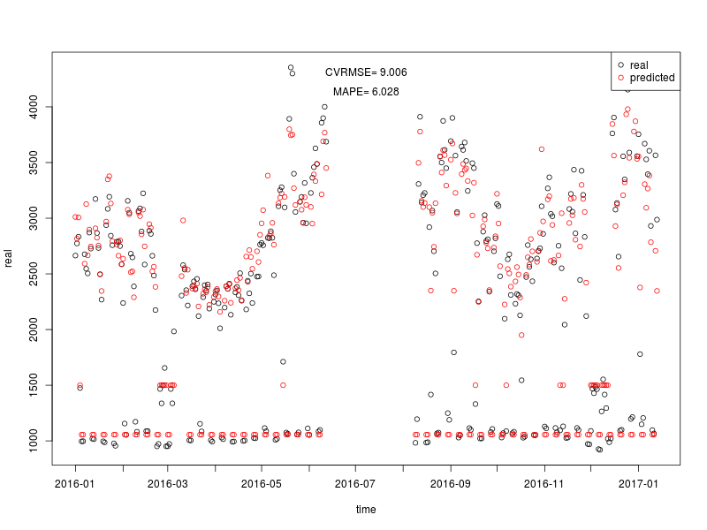

Conclusions
[Write conclusions]

THINGS:
International Performance Measurement and Verification Protocol

